Dsm-Dev 04-12-2025 MANUAL

Introduction:

As part of the quality assurance process, a manual audit has been initiated to validate the results generated by the automated vulnerability scanning tools. Each finding is being reviewed to determine its accuracy and relevance, with the objective of classifying them as either true positives (valid security issues) or false positives (non-exploitable or misidentified issues).
This step ensures the reliability of the final report by eliminating noise from automated tools and confirming the presence and impact of vulnerabilities through manual testing techniques. The scan is done twice a month

Table of Contents
Introduction: 2
2025 Q2 CSOC Manual Penetration test of Test-Portal 4
Executive Summary 4
SQL Injection 4
TLS Certificate 6
Client Side JSON Injection (DOM-Based) 7
Cookie Manipulation (DOM Based) 9
Cross Site Scripting (stored) 10
Content Security Policy Allow listed Script Resources 11
Content Security Policy Untrusted Script execution 13
Content Security Policy Untrusted Style Execution 17
Input Returned in Response (stored) 25
Input Returned in Response (Reflected) 27
HTML5 Storage Manipulation Test (DOM Based) 29
Email address disclosed 30
Cacheable HTTPS Response 30

2025 Q2 CSOC Manual Penetration test of Test-Portal

Executive Summary
The chart below shows the aggregated numbers of issues identified in each category. Solid colored bars represent issues with a confidence level of Certain, and the bars fade as the confidence level falls

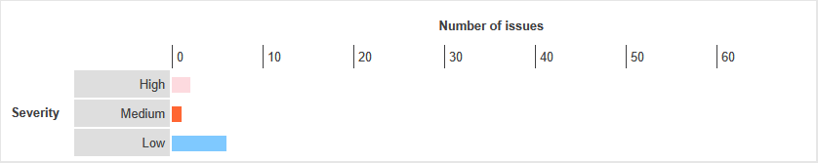

SQL Injection
Severity | NA
Finding Type | False Positive

Description
SQL injection vulnerabilities arise when user-controllable data is incorporated into database SQL queries in an unsafe manner. An attacker can supply crafted input to break out of the data context in which their input appears and interfere with the structure of the surrounding query.
A wide range of damaging attacks can often be delivered via SQL injection, including reading or modifying critical application data, interfering with application logic, escalating privileges within the database and taking control of the database server.
Links Tested
- /api/v1/stats/sla-summary [endDate parameter]
- /api/v1/stats/sla-summary [startDate parameter]
Steps
Login into dsm-dev.zalaris.com
Crawl the application and capture the request reported with SQL injection
Forward the request to Intruder add a placeholder value payload injection area
Start the attack and analyze the response , no SQL injection related information is received
Refer Screensot for evidence
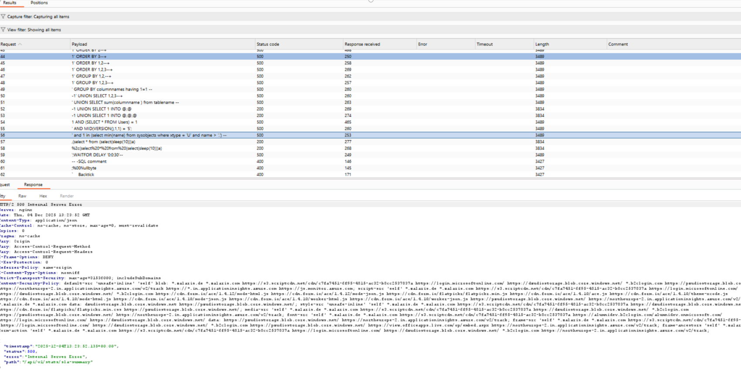

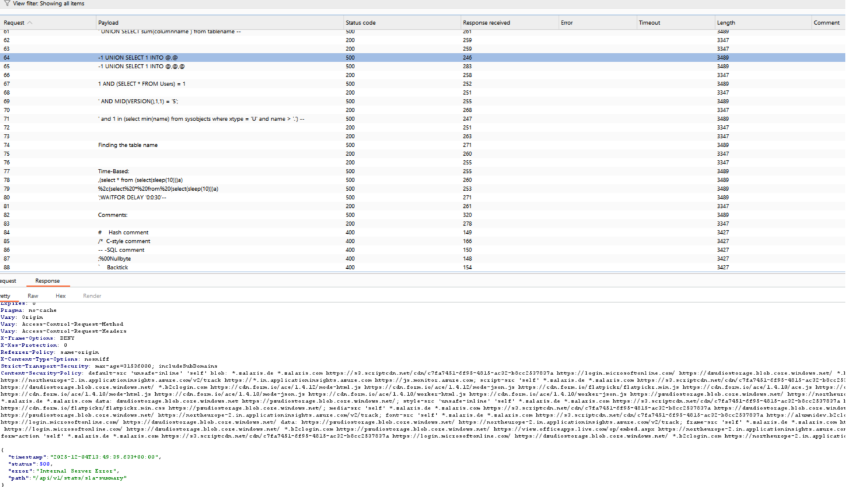

The server returns 500 Internal Server Error and does not give any information related to SQL injection. Alert is False positive

WORKLOG

When | What | Who | Recommended Action
05-11-2025 | Manually Tested the SQL Injection alert | CSOC | No Action Needed the alert is false positive

TLS Certificate

Severity | NA
Finding Type | Informational

Description
The following problems were identified with the server's TLS certificate:
- The server's certificate is not valid for the server's hostname.
- The server's certificate is not trusted.
Note: Burp relies on the Java trust store to determine whether certificates are trusted. The Java trust store does not include every root CA certificate that is included within browser trust stores. Burp might incorrectly report that a certificate is not trusted, if a valid root CA certificate is being used that is not included in the Java trust store.
The server presented the following certificate:
Issued to: | support.zalaris.de, *.az.zalaris.de, *.hr-box.zalaris.de, *.int.zalaris.de, *.sk.zalaris.de, *.sv-fr.zalaris.de, *.wwn.zalaris.de, *.zalaris.de
Issued by: | DigiCert Global G2 TLS RSA SHA256 2020 CA1
Valid from: | Fri Aug 08 05:30:00 IST 2025

Overall Score
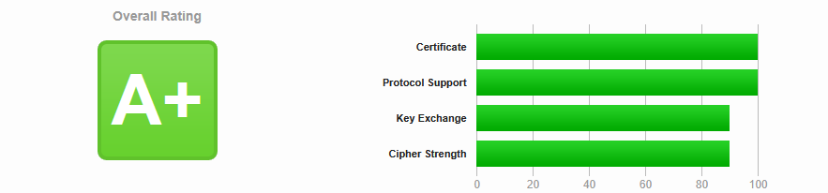
Certificate Validity
SSL/TLS certificate validation confirmed the certificate is active and within its validity period as of he test date
TLS protocols supported

The target supports TLS protocols supported are 1.2 and 1.3 which are considered as secure for current use

Cipher Suites supported

The following cipher suites are used and are secure

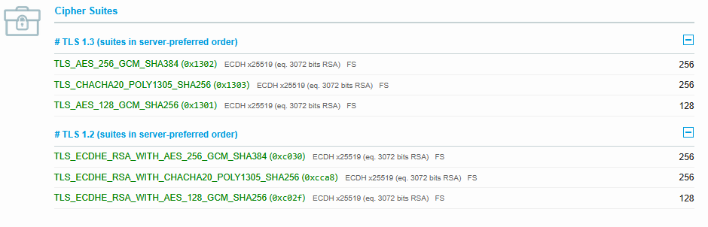
No Issues are found the alert is informational

WORKLOG
When | What | Who | Recommended Action
05-12-2025 | Manually Tested TLS Certificate alert for issues | CSOC | No action needed alert is informational

Client Side JSON Injection (DOM-Based)

Severity | NA
Finding Type | Informational

Description
DOM-based vulnerabilities arise when a client-side script reads data from a controllable part of the DOM (for example, the URL) and processes this data in an unsafe way.
DOM-based JSON injection arises when a script incorporates controllable data into a string that is parsed as a JSON data structure and then processed by the application. An attacker may be able to use this behavior to construct a URL that, if visited by another application user, will cause arbitrary JSON data to be processed. Depending on the purpose for which this data is used, it may be possible to subvert the application's logic, or cause unintended actions on behalf of the user.
Burp Suite automatically identifies this issue using dynamic and static code analysis. Static analysis can lead to false positives that are not actually exploitable. If Burp Scanner has not provided any evidence resulting from dynamic analysis, you should review the relevant code and execution paths to determine whether this vulnerability is indeed present, or whether mitigations are in place that would prevent exploitation.

Links Tested
- /
- /777
- /undefined
The reported Issues was
Data is read from document.cookie and passed to JSON.parse.
The following value was injected into the source:
w4avqt7v4o%2527%2522`'"/w4avqt7v4o/><w4avqt7v4o/\>oxw6yxgos5&
The previous value reached the sink as:
w4avqt7v4o%27%22`'"/w4avqt7v4o/><w4avqt7v4o/\>oxw6yxgos5&

Steps

- The reported issue is that the application reads input from document.cookie and passed it to JSON.Parse
- Verify that the application reads document.cookie and passes it to JSON Parse
- This can be done by a small monkey patch
const originalParse = JSON.parse;
JSON.parse = function(input) {
console.log("[JSON.parse CALLED WITH]:", input);
return originalParse.call(this, input);
};

- Reload the page
- JSON Parse is calling the cookie value
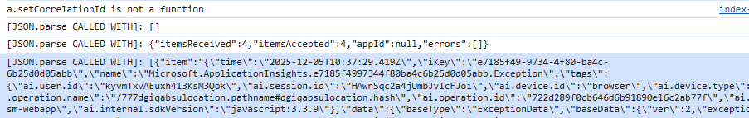
- Login to Dsm-dev.zalaris.com document.cookie = "domtest=<img src=x onerror=console.log('DOM_XSS_FIRE')>; path=/";
- Reload Page observe console for XSS
- No XSS is received for the application
- Here is an automated script that be used to test the same

// Automated DOM XSS detection
document.cookie = "domtest=<img src=x onerror=console.log('DOM_XSS_FIRE')>; path=/";

setTimeout(() => {
let fired = false;

const log = console.log;
console.log = function (...args) {
if (args.includes("DOM_XSS_FIRE")) {
fired = true;
}
log.apply(console, args);
};

setTimeout(() => {
if (fired) {
console.error(" DOM XSS CONFIRMED – Payload executed!");
} else {
console.warn(" Reflective HTML found, but payload NOT executed (may be sanitized).");
}
}, 1500);

}, 300);

When the script is run the console confirms that reflective HTML is found but is not executed
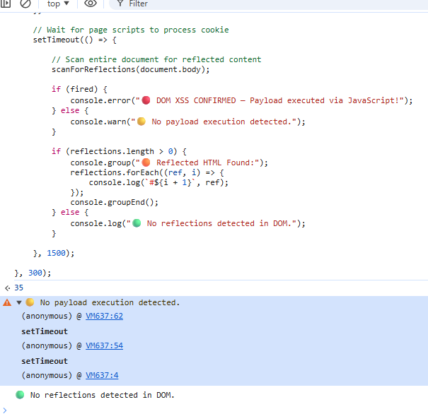
WORKLOG
When | What | Who | Recommended Action
05-12-2025 | Manually tested client side JSON injection (DOM based) | CSOC | No action needed the alert is false positive

Cookie Manipulation (DOM Based)

Severity | NA
Finding Type | False Positive

Description

DOM-based vulnerabilities arise when a client-side script reads data from a controllable part of the DOM (for example, the URL) and processes this data in an unsafe way.
DOM-based cookie manipulation arises when a script writes controllable data into the value of a cookie. An attacker may be able to use the vulnerability to construct a URL that, if visited by another application user, will set an arbitrary value in the user's cookie.
The potential impact of the vulnerability depends on the role that the cookie plays within the application. If the cookie is used to control the behavior that results from certain user actions (for example, a 'production' versus 'demo' mode setting), then the attacker may be able to cause the user to perform unintended actions by manipulating the cookie's value. If the cookie is used to track the user's session, then the attacker may be able to perform a session fixation attack, in which they set the cookie's value to a valid token that they have obtained from the application, and then hijack the session during the victim user's subsequent interaction with the application.
Burp Suite automatically identifies this issue using dynamic and static code analysis. Static analysis can lead to false positives that are not actually exploitable. If Burp Scanner has not provided any evidence resulting from dynamic analysis, you should review the relevant code and execution paths to determine whether this vulnerability is indeed present, or whether mitigations are in place that would prevent exploitation.

Links Reported
- /
- /777
- /undefined
Details
No user controlled parameter is available to alter the cookie in dsm-dev.zalaris.com
The alert is considered as false positive
WORKLOG
When | What | Who | Recommended Action
05-12-2025 | Manually Tested Cookie manipulation (DOM Based) | CSOC | False Positive no action needed

Cross Site Scripting (stored)

Severity | NA
Finding Type | False Positive

Description

The value of the name JSON parameter submitted to the URL /api/v1/org/clients/230/regions/no/contact-book is copied into the HTML document as plain text between tags at the URL /api/v1/org/clients/230/regions/no. The payload zkmim<script>alert(1)</script>l054b was submitted in the name JSON parameter. This input was returned unmodified in a subsequent request for the URL /api/v1/org/clients/230/regions/no.
This proof-of-concept attack demonstrates that it is possible to inject arbitrary JavaScript into the application's response.
The response does not state that the content type is HTML. The issue is only directly exploitable if a browser can be made to interpret the response as HTML. No modern browser will interpret the response as HTML. However, the issue might be indirectly exploitable if a client-side script processes the response and embeds it into an HTML context.

Links Reported
- /api/v1/org/clients/230/regions/no/contact-book
Steps
- Login into the application and access the contacts page
- Inject the contact field with XSS payload and analyse the response for XSS
- The response shows that the injected script is stored but is sanitized . The alert is false positive.
- Refer screenshot for evidence
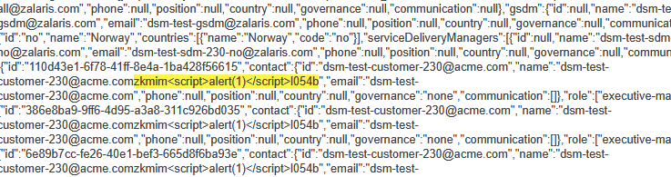
WORKLOG
When | What | Who | Recommended Action
05-12-2025 | Manually Tested Cross Site Scripting (Stored) | CSOC | False Positive no action needed

Content Security Policy Allow listed Script Resources
Severity | NA
Finding Type | False Positive

Description
The content security policy fails to prevent un-trusted JavaScript from being executed. As a result, it may fail to mitigate cross-site scripting attacks.The policy has the following issues:The policy contains unsafe-inline which can allow arbitrary scripts to be executed.
Links Tested
- /
Steps
The CSP for dsm-dev.zalaris.com is given below
default-src 'unsafe-inline' 'self' blob: *.zalaris.de *.zalaris.com https://s3.scriptcdn.net/cdn/c7fa7451-6f95-4815-ac32-b8cc2537837a https://login.microsoftonline.com/ https://dzudiostorage.blob.core.windows.net/ *.b2clogin.com https://pzudiostorage.blob.core.windows.net/ https://northeurope-2.in.applicationinsights.azure.com/v2/track https://*.in.applicationinsights.azure.com https://js.monitor.azure.com;
script-src 'self' *.zalaris.de *.zalaris.com https://s3.scriptcdn.net/cdn/c7fa7451-6f95-4815-ac32-b8cc2537837a https://login.microsoftonline.com/ https://dzudiostorage.blob.core.windows.net/ *.b2clogin.com https://cdn.form.io/ace/1.4.12/mode-html.js https://cdn.form.io/ace/1.4.12/mode-json.js https://cdn.form.io/flatpickr/flatpickr.min.js https://cdn.form.io/ace/1.4.10/ace.js https://cdn.form.io/ace/1.4.10/theme-xcode.js https://cdn.form.io/ace/1.4.10/mode-html.js https://cdn.form.io/ace/1.4.10/mode-json.js https://cdn.form.io/ace/1.4.10/worker-html.js https://cdn.form.io/ace/1.4.10/worker-json.js https://pzudiostorage.blob.core.windows.net/ https://northeurope-2.in.applicationinsights.azure.com/v2/track;
img-src 'self' *.zalaris.de *.zalaris.com data: dzudiostorage.blob.core.windows.net https://pzudiostorage.blob.core.windows.net/;
style-src 'unsafe-inline' 'self' *.zalaris.de *.zalaris.com https://s3.scriptcdn.net/cdn/c7fa7451-6f95-4815-ac32-b8cc2537837a https://dzudiostorage.blob.core.windows.net/ *.b2clogin.com https://cdn.form.io/flatpickr/flatpickr.min.css https://pzudiostorage.blob.core.windows.net/;
media-src 'self' *.zalaris.de *.zalaris.com https://s3.scriptcdn.net/cdn/c7fa7451-6f95-4815-ac32-b8cc2537837a https://dzudiostorage.blob.core.windows.net/ *.b2clogin.com https://pzudiostorage.blob.core.windows.net/ https://northeurope-2.in.applicationinsights.azure.com/v2/track;
font-src 'self' *.zalaris.de *.zalaris.com https://s3.scriptcdn.net/cdn/c7fa7451-6f95-4815-ac32-b8cc2537837a https://alumnidev.b2clogin.com/alumnidev.onmicrosoft.com/ https://login.microsoftonline.com/ https://dzudiostorage.blob.core.windows.net/ data: https://pzudiostorage.blob.core.windows.net/ https://northeurope-2.in.applicationinsights.azure.com/v2/track;
frame-src 'self' *.zalaris.de *.zalaris.com https://s3.scriptcdn.net/cdn/c7fa7451-6f95-4815-ac32-b8cc2537837a https://login.microsoftonline.com/ https://dzudiostorage.blob.core.windows.net/ *.b2clogin.com https://pzudiostorage.blob.core.windows.net/ https://view.officeapps.live.com/op/embed.aspx https://northeurope-2.in.applicationinsights.azure.com/v2/track;
frame-ancestors 'self' *.zalaris.de *.zalaris.com;
form-action 'self' *.zalaris.de *.zalaris.com https://s3.scriptcdn.net/cdn/c7fa7451-6f95-4815-ac32-b8cc2537837a https://login.microsoftonline.com/ https://dzudiostorage.blob.core.windows.net/ *.b2clogin.com https://northeurope-2.in.applicationinsights.azure.com/v2/track;

Whitelisted domains must **not host user-uploaded content**- Condition met
-No user uploaded js files are present
Whitelisted domains must **not host modifiable JSON/JS**-Condition met
-No user midifiable js file is present
Whitelisted domains must **not allow query-based reflection**-Condition met
-the whitelisted scripts are not allowing query based reflection
CDN must be **versioned**-Condition met
-The script from the CDN is versioned
CDN must be **immutable**-Condition met
-The CDN is immutable
No wildcard subdomains-Condition met
Wild card subdomains are present but are owned by zalaris
No wildcard paths-Condition met
-wild card domains are present but are owned by Zalaris
WORKLOG

When | What | Who | Recommended Action
05-12-2025 | Manually Tested Content Security Policy allow listed Script resources | CSOC | No Action Needed Alert is Informational

Content Security Policy Untrusted Script execution
Severity | NA
Finding Type | False Positive

Description
The content security policy fails to prevent un-trusted JavaScript from being executed. As a result, it may fail to mitigate cross-site scripting attacks.The policy has the following issues:The policy contains unsafe-inline which can allow arbitrary scripts to be executed.
Links Tested
- /
Steps
The CSP for dsm-dev.zalaris.com is given below
default-src 'unsafe-inline' 'self' blob: *.zalaris.de *.zalaris.com https://s3.scriptcdn.net/cdn/c7fa7451-6f95-4815-ac32-b8cc2537837a https://login.microsoftonline.com/ https://dzudiostorage.blob.core.windows.net/ *.b2clogin.com https://pzudiostorage.blob.core.windows.net/ https://northeurope-2.in.applicationinsights.azure.com/v2/track https://*.in.applicationinsights.azure.com https://js.monitor.azure.com;
script-src 'self' *.zalaris.de *.zalaris.com https://s3.scriptcdn.net/cdn/c7fa7451-6f95-4815-ac32-b8cc2537837a https://login.microsoftonline.com/ https://dzudiostorage.blob.core.windows.net/ *.b2clogin.com https://cdn.form.io/ace/1.4.12/mode-html.js https://cdn.form.io/ace/1.4.12/mode-json.js https://cdn.form.io/flatpickr/flatpickr.min.js https://cdn.form.io/ace/1.4.10/ace.js https://cdn.form.io/ace/1.4.10/theme-xcode.js https://cdn.form.io/ace/1.4.10/mode-html.js https://cdn.form.io/ace/1.4.10/mode-json.js https://cdn.form.io/ace/1.4.10/worker-html.js https://cdn.form.io/ace/1.4.10/worker-json.js https://pzudiostorage.blob.core.windows.net/ https://northeurope-2.in.applicationinsights.azure.com/v2/track;
img-src 'self' *.zalaris.de *.zalaris.com data: dzudiostorage.blob.core.windows.net https://pzudiostorage.blob.core.windows.net/;
style-src 'unsafe-inline' 'self' *.zalaris.de *.zalaris.com https://s3.scriptcdn.net/cdn/c7fa7451-6f95-4815-ac32-b8cc2537837a https://dzudiostorage.blob.core.windows.net/ *.b2clogin.com https://cdn.form.io/flatpickr/flatpickr.min.css https://pzudiostorage.blob.core.windows.net/;
media-src 'self' *.zalaris.de *.zalaris.com https://s3.scriptcdn.net/cdn/c7fa7451-6f95-4815-ac32-b8cc2537837a https://dzudiostorage.blob.core.windows.net/ *.b2clogin.com https://pzudiostorage.blob.core.windows.net/ https://northeurope-2.in.applicationinsights.azure.com/v2/track;
font-src 'self' *.zalaris.de *.zalaris.com https://s3.scriptcdn.net/cdn/c7fa7451-6f95-4815-ac32-b8cc2537837a https://alumnidev.b2clogin.com/alumnidev.onmicrosoft.com/ https://login.microsoftonline.com/ https://dzudiostorage.blob.core.windows.net/ data: https://pzudiostorage.blob.core.windows.net/ https://northeurope-2.in.applicationinsights.azure.com/v2/track;
frame-src 'self' *.zalaris.de *.zalaris.com https://s3.scriptcdn.net/cdn/c7fa7451-6f95-4815-ac32-b8cc2537837a https://login.microsoftonline.com/ https://dzudiostorage.blob.core.windows.net/ *.b2clogin.com https://pzudiostorage.blob.core.windows.net/ https://view.officeapps.live.com/op/embed.aspx https://northeurope-2.in.applicationinsights.azure.com/v2/track;
frame-ancestors 'self' *.zalaris.de *.zalaris.com;
form-action 'self' *.zalaris.de *.zalaris.com https://s3.scriptcdn.net/cdn/c7fa7451-6f95-4815-ac32-b8cc2537837a https://login.microsoftonline.com/ https://dzudiostorage.blob.core.windows.net/ *.b2clogin.com https://northeurope-2.in.applicationinsights.azure.com/v2/track;

The following script detects whether un-trusted scripts are allowed to be executed
console.log("%c[TEST] Untrusted Script Execution", "color:red;font-size:16px;");

let R = {
inlineExecuted: false,
evalExecuted: false,
functionExecuted: false,
blobExecuted: false,
dataExecuted: false,
notes: []
};

// Inline Script
try {
let s = document.createElement("script");
s.innerHTML = "window.__INLINE_EXEC=true";
document.body.appendChild(s);
R.inlineExecuted = window.__INLINE_EXEC === true;
} catch(e){ R.notes.push("inline script blocked"); }

// eval()
try {
eval("window.__EVAL_EXEC=true");
R.evalExecuted = window.__EVAL_EXEC === true;
} catch(e){ R.notes.push("eval blocked"); }

// Function()
try {
Function("window.__FUNC_EXEC=true")();
R.functionExecuted = window.__FUNC_EXEC === true;
} catch(e){ R.notes.push("Function() blocked"); }

// blob:
try {
let blob = new Blob(["window.__BLOB_EXEC=true"], {type:"application/javascript"});
let url = URL.createObjectURL(blob);
let s = document.createElement("script");
s.src = url;
document.body.appendChild(s);
setTimeout(()=> R.blobExecuted = window.__BLOB_EXEC===true, 200);
} catch(e){ R.notes.push("blob blocked"); }

// data:
try {
let d = document.createElement("script");
d.src = "data:text/javascript,window.__DATA_EXEC=true";
document.body.appendChild(d);
setTimeout(()=> R.dataExecuted = window.__DATA_EXEC===true, 200);
} catch(e){ R.notes.push("data: blocked"); }

setTimeout(()=> console.table(R), 500);
Script gave the following result
- Blob based script execution failed
- Data based script execution failed
- Eval function targeted script execution failed
- Custom function script execution failed
- Inline script execution failed
- Refer Screenshot attached for evidence
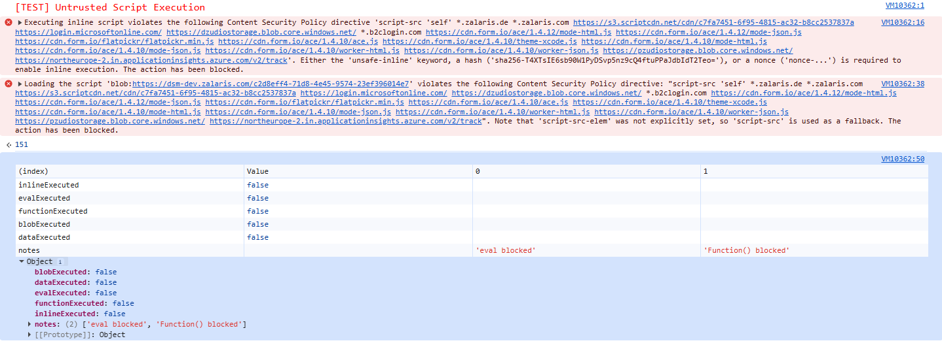
WORKLOG

When | What | Who | Recommended Action
05-12-2025 | Manually Tested Content Security Policy allow Untrusted Script Execution | CSOC | No Action Needed Alert is Informational

Content Security Policy Untrusted Style Execution
Severity
Finding Type

Description
The content security policy fails to prevent Untrusted style execution. As a result, it may fail to mitigate style based data ex-filtration.The policy contains unsafe-inline which can allow arbitrary styles to be executed.
Links Tested
- /
- 777
- /api/v1/dash/news/670509dee31630728bc84a22
Steps
The CSP for dsm-dev.zalaris.com is given below
default-src 'unsafe-inline' 'self' blob: *.zalaris.de *.zalaris.com https://s3.scriptcdn.net/cdn/c7fa7451-6f95-4815-ac32-b8cc2537837a https://login.microsoftonline.com/ https://dzudiostorage.blob.core.windows.net/ *.b2clogin.com https://pzudiostorage.blob.core.windows.net/ https://northeurope-2.in.applicationinsights.azure.com/v2/track https://*.in.applicationinsights.azure.com https://js.monitor.azure.com;
script-src 'self' *.zalaris.de *.zalaris.com https://s3.scriptcdn.net/cdn/c7fa7451-6f95-4815-ac32-b8cc2537837a https://login.microsoftonline.com/ https://dzudiostorage.blob.core.windows.net/ *.b2clogin.com https://cdn.form.io/ace/1.4.12/mode-html.js https://cdn.form.io/ace/1.4.12/mode-json.js https://cdn.form.io/flatpickr/flatpickr.min.js https://cdn.form.io/ace/1.4.10/ace.js https://cdn.form.io/ace/1.4.10/theme-xcode.js https://cdn.form.io/ace/1.4.10/mode-html.js https://cdn.form.io/ace/1.4.10/mode-json.js https://cdn.form.io/ace/1.4.10/worker-html.js https://cdn.form.io/ace/1.4.10/worker-json.js https://pzudiostorage.blob.core.windows.net/ https://northeurope-2.in.applicationinsights.azure.com/v2/track;
img-src 'self' *.zalaris.de *.zalaris.com data: dzudiostorage.blob.core.windows.net https://pzudiostorage.blob.core.windows.net/;
style-src 'unsafe-inline' 'self' *.zalaris.de *.zalaris.com https://s3.scriptcdn.net/cdn/c7fa7451-6f95-4815-ac32-b8cc2537837a https://dzudiostorage.blob.core.windows.net/ *.b2clogin.com https://cdn.form.io/flatpickr/flatpickr.min.css https://pzudiostorage.blob.core.windows.net/;
media-src 'self' *.zalaris.de *.zalaris.com https://s3.scriptcdn.net/cdn/c7fa7451-6f95-4815-ac32-b8cc2537837a https://dzudiostorage.blob.core.windows.net/ *.b2clogin.com https://pzudiostorage.blob.core.windows.net/ https://northeurope-2.in.applicationinsights.azure.com/v2/track;
font-src 'self' *.zalaris.de *.zalaris.com https://s3.scriptcdn.net/cdn/c7fa7451-6f95-4815-ac32-b8cc2537837a https://alumnidev.b2clogin.com/alumnidev.onmicrosoft.com/ https://login.microsoftonline.com/ https://dzudiostorage.blob.core.windows.net/ data: https://pzudiostorage.blob.core.windows.net/ https://northeurope-2.in.applicationinsights.azure.com/v2/track;
frame-src 'self' *.zalaris.de *.zalaris.com https://s3.scriptcdn.net/cdn/c7fa7451-6f95-4815-ac32-b8cc2537837a https://login.microsoftonline.com/ https://dzudiostorage.blob.core.windows.net/ *.b2clogin.com https://pzudiostorage.blob.core.windows.net/ https://view.officeapps.live.com/op/embed.aspx https://northeurope-2.in.applicationinsights.azure.com/v2/track;
frame-ancestors 'self' *.zalaris.de *.zalaris.com;
form-action 'self' *.zalaris.de *.zalaris.com https://s3.scriptcdn.net/cdn/c7fa7451-6f95-4815-ac32-b8cc2537837a https://login.microsoftonline.com/ https://dzudiostorage.blob.core.windows.net/ *.b2clogin.com https://northeurope-2.in.applicationinsights.azure.com/v2/track;
The following conditions must be met for the application to be vulnerable for Unstrusted Style Execution
- The application itself loads the untrusted stylesheet automatically due to user-controllable input.
There are no endpoints that loads the untrusted style sheet due to the user -controllable input
https://dsm-dev.zalaris.com/
https://dsm-dev.zalaris.com/777
https://dsm-dev.zalaris.com/777/
https://dsm-dev.zalaris.com/777/contacts/230/no
https://dsm-dev.zalaris.com/777/dgiqscan4-/777/dgiqscan2-%22%3E%3Cimg%20src=x%20onerror=alert(1)%3E
https://dsm-dev.zalaris.com/777/dgiqscan4-/777/dgiqscan3-%22%3E%3Csvg/onload=alert(1337)%3E
https://dsm-dev.zalaris.com/777/dgiqscan4-/777/dgiqscan4-/777/statisticsdgiqabsulocation.pathname
https://dsm-dev.zalaris.com/777/invoices
https://dsm-dev.zalaris.com/777/service-reports
https://dsm-dev.zalaris.com/777/statistics
https://dsm-dev.zalaris.com/777dgiqabsulocation.pathname/dgiqscan4-/777dgiqabsulocation.pathname/dgiqscan2-%22%3E%3Cimg%20src=x%20onerror=alert(1)%3E
https://dsm-dev.zalaris.com/777dgiqabsulocation.pathname/dgiqscan4-/777dgiqabsulocation.pathname/dgiqscan3-%22%3E%3Csvg/onload=alert(1337)%3E
https://dsm-dev.zalaris.com/777dgiqabsulocation.pathname/dgiqscan4-/777dgiqabsulocation.pathname/dgiqscan4-/777dgiqabsulocation.pathname/invoicesdgiqabsulocation.pathname
https://dsm-dev.zalaris.com/777dgiqabsulocation.pathname/invoices
https://dsm-dev.zalaris.com/777dgiqabsulocation.pathname/service-reports
https://dsm-dev.zalaris.com/777dgiqabsulocation.pathname/service-reports/693188cd9c36540bd336cd30/edit
https://dsm-dev.zalaris.com/777dgiqabsulocation.pathname/service-reports/693188cd9c36540bd336cd30/edit?x=dgiqabsu
https://dsm-dev.zalaris.com/777dgiqabsulocation.pathname/statistics
https://dsm-dev.zalaris.com/api/v1/dash/news
https://dsm-dev.zalaris.com/api/v1/dash/news/670509dee31630728bc84a22
https://dsm-dev.zalaris.com/api/v1/dash/news/670509dee31630728bc84a22?clientId=230
https://dsm-dev.zalaris.com/api/v1/dash/news?clientId=230
https://dsm-dev.zalaris.com/api/v1/fin/invoice-parties
https://dsm-dev.zalaris.com/api/v1/fin/invoices
https://dsm-dev.zalaris.com/api/v1/fin/invoices/400009731002
https://dsm-dev.zalaris.com/api/v1/fin/invoices/400009731002dgiqabsulocation.pathname
https://dsm-dev.zalaris.com/api/v1/fin/invoices/400009731201
https://dsm-dev.zalaris.com/api/v1/fin/invoices/40000973201
https://dsm-dev.zalaris.com/api/v1/fin/invoices/40000973401
https://dsm-dev.zalaris.com/api/v1/fin/invoices?partyIds=40000973&billDate=2025-11&page=0&per_page=100
https://dsm-dev.zalaris.com/api/v1/fin/invoices?partyIds=40000973&billDate=2025-11&page=0&per_page=20
https://dsm-dev.zalaris.com/api/v1/fin/invoices?partyIds=40000973&billDate=2025-12&page=0&per_page=100
https://dsm-dev.zalaris.com/api/v1/fin/invoices?partyIds=40000973&billDate=2025-12&page=0&per_page=20
https://dsm-dev.zalaris.com/api/v1/fin/invoices?partyIds=40000973&billDate=2025-12&page=0&per_page=50
https://dsm-dev.zalaris.com/api/v1/fin/invoices?partyIds=40000973&billDate=2025-12&page=1&per_page=20
https://dsm-dev.zalaris.com/api/v1/org/clients/230
https://dsm-dev.zalaris.com/api/v1/org/clients/230/contract-dates
https://dsm-dev.zalaris.com/api/v1/org/clients/230/contract-dates
https://dsm-dev.zalaris.com/api/v1/org/clients/230/contract-dates
https://dsm-dev.zalaris.com/api/v1/org/clients/230/general-information
https://dsm-dev.zalaris.com/api/v1/org/clients/230/general-information
https://dsm-dev.zalaris.com/api/v1/org/clients/230/general-information
https://dsm-dev.zalaris.com/api/v1/org/clients/230/regions
https://dsm-dev.zalaris.com/api/v1/org/clients/230/regions
https://dsm-dev.zalaris.com/api/v1/org/clients/230/regions
https://dsm-dev.zalaris.com/api/v1/org/clients/230/regions/eu-north-1
https://dsm-dev.zalaris.com/api/v1/org/clients/230/regions/eu-north-1/contact-book
https://dsm-dev.zalaris.com/api/v1/org/clients/230/regions/eu-north-1/contact-book
https://dsm-dev.zalaris.com/api/v1/org/clients/230/regions/no
https://dsm-dev.zalaris.com/api/v1/org/clients/230/regions/se
https://dsm-dev.zalaris.com/api/v1/org/clients/230/regions/se/contact-book/329ea077-dae8-4319-893f-959e58f2081e
https://dsm-dev.zalaris.com/api/v1/org/clients/230/regions/se/contact-book/329ea077-dae8-4319-893f-959e58f2081e
https://dsm-dev.zalaris.com/api/v1/org/clients/230/services
https://dsm-dev.zalaris.com/api/v1/org/clients/230/services
https://dsm-dev.zalaris.com/api/v1/org/clients/230/services
https://dsm-dev.zalaris.com/api/v1/org/clients/230/services
https://dsm-dev.zalaris.com/api/v1/org/clients/definitions
https://dsm-dev.zalaris.com/api/v1/org/contacts/dsm-test-gsdm%40zalaris.com/avatar
https://dsm-dev.zalaris.com/api/v1/org/contacts/dsm-test-sdm-230-no%40zalaris.com/avatar
https://dsm-dev.zalaris.com/api/v1/org/contacts/jens.jensen%40acme.com/avatar
https://dsm-dev.zalaris.com/api/v1/org/contacts/jens.jensen@acme.com/N/A%20-%20The%20repository%20is%20internal%20to%20Google
https://dsm-dev.zalaris.com/api/v1/org/contacts/jens.jensen@acme.com/This%20is%20the%20canonical%20public%20repository
https://dsm-dev.zalaris.com/api/v1/org/contacts/lucja.roczniak%40zalaris.com/avatar
https://dsm-dev.zalaris.com/api/v1/org/contacts/petter.person%40acme.com/avatar
https://dsm-dev.zalaris.com/api/v1/org/contacts/vinoth.padmanaban%40zalaris.com/avatar
https://dsm-dev.zalaris.com/api/v1/org/contacts/vinothkumar.murugan%40zalaris.com/avatar
https://dsm-dev.zalaris.com/api/v1/service-reports
https://dsm-dev.zalaris.com/api/v1/service-reports
https://dsm-dev.zalaris.com/api/v1/service-reports/693188cd9c36540bd336cd29
https://dsm-dev.zalaris.com/api/v1/service-reports/693188cd9c36540bd336cd29/action-points
https://dsm-dev.zalaris.com/api/v1/service-reports/693188cd9c36540bd336cd29/notes
https://dsm-dev.zalaris.com/api/v1/service-reports/693188cd9c36540bd336cd2c
https://dsm-dev.zalaris.com/api/v1/service-reports/693188cd9c36540bd336cd2c/notes
https://dsm-dev.zalaris.com/api/v1/service-reports/693188cd9c36540bd336cd30
https://dsm-dev.zalaris.com/api/v1/service-reports/693188cd9c36540bd336cd30/action-points
https://dsm-dev.zalaris.com/api/v1/service-reports/693188cd9c36540bd336cd30/action-points
https://dsm-dev.zalaris.com/api/v1/service-reports/693188cd9c36540bd336cd30/action-points/6405032b-a0df-4aab-91b0-7449df43ca1a
https://dsm-dev.zalaris.com/api/v1/service-reports/693188cd9c36540bd336cd30/action-points/6405032b-a0df-4aab-91b0-7449df43ca1a
https://dsm-dev.zalaris.com/api/v1/service-reports/693188cd9c36540bd336cd30/action-points/6405032b-a0df-4aab-91b0-7449df43ca1a
https://dsm-dev.zalaris.com/api/v1/service-reports/693188cd9c36540bd336cd30/notes
https://dsm-dev.zalaris.com/api/v1/service-reports/693188cd9c36540bd336cd30/notes
https://dsm-dev.zalaris.com/api/v1/service-reports?clientId=230&regionId=eu-north-1&type=OPERATIONAL
https://dsm-dev.zalaris.com/api/v1/service-reports?clientId=230&regionId=no&type=OPERATIONAL
https://dsm-dev.zalaris.com/api/v1/service-reports?clientId=230&regionId=se&type=OPERATIONAL
https://dsm-dev.zalaris.com/api/v1/service-reports?clientId=230&type=STRATEGIC
https://dsm-dev.zalaris.com/api/v1/service-reports?clientId=230&type=TACTICAL
https://dsm-dev.zalaris.com/api/v1/stats/active-employee-group
https://dsm-dev.zalaris.com/api/v1/stats/active-employee-group?clientId=230&startMonthYear=20250101&endMonthYear=20251205
https://dsm-dev.zalaris.com/api/v1/stats/active-employee-group?clientId=230&startMonthYear=20250101&endMonthYear=20251211
https://dsm-dev.zalaris.com/api/v1/stats/active-employee-group?clientId=230&startMonthYear=20250101&endMonthYear=20251219
https://dsm-dev.zalaris.com/api/v1/stats/active-employees
https://dsm-dev.zalaris.com/api/v1/stats/active-employees?clientId=230&startMonthYear=20250101&endMonthYear=20251205
https://dsm-dev.zalaris.com/api/v1/stats/active-employees?clientId=230&startMonthYear=20250101&endMonthYear=20251211
https://dsm-dev.zalaris.com/api/v1/stats/client-summary
https://dsm-dev.zalaris.com/api/v1/stats/client-summary?clientId=230&startMonthYear=20250101&endMonthYear=20251205
https://dsm-dev.zalaris.com/api/v1/stats/client-summary?clientId=230&startMonthYear=20250101&endMonthYear=20251211
https://dsm-dev.zalaris.com/api/v1/stats/payroll-summary
https://dsm-dev.zalaris.com/api/v1/stats/payroll-summary?clientId=230&startMonthYear=20250101&endMonthYear=20251205
https://dsm-dev.zalaris.com/api/v1/stats/payroll-summary?clientId=230&startMonthYear=20250101&endMonthYear=20251211
https://dsm-dev.zalaris.com/api/v1/users/me
https://dsm-dev.zalaris.com/assets/actionButtonStyles-D61Tvsxh.js
https://dsm-dev.zalaris.com/assets/array-arcOQjQo.js
https://dsm-dev.zalaris.com/assets/confirmation-modal-dQjSs2T7.js
https://dsm-dev.zalaris.com/assets/counter-parts-CahpHHAv.js
https://dsm-dev.zalaris.com/assets/country-selector-DZzur1qB.js
https://dsm-dev.zalaris.com/assets/customer-page-dBX4Umug.js
https://dsm-dev.zalaris.com/assets/datetime-n6HvnmwO.js
https://dsm-dev.zalaris.com/assets/Dropdown-BxwbN3mg.js
https://dsm-dev.zalaris.com/assets/empty-QscNFAPH.js
https://dsm-dev.zalaris.com/assets/gapSize-5X2suo7C.js
https://dsm-dev.zalaris.com/assets/general-styles-D8uevKv6.js
https://dsm-dev.zalaris.com/assets/global-table-CT-HEcOe.js
https://dsm-dev.zalaris.com/assets/index-7a7MI-Fd.js
https://dsm-dev.zalaris.com/assets/index-B_k6UzEc.js
https://dsm-dev.zalaris.com/assets/index-BegA90Gu.js
https://dsm-dev.zalaris.com/assets/index-BNIQMCuc.js
https://dsm-dev.zalaris.com/assets/index-BRkEFArC.js
https://dsm-dev.zalaris.com/assets/index-CKsXwbVh.js
https://dsm-dev.zalaris.com/assets/index-CS-lONU9.js
https://dsm-dev.zalaris.com/assets/index-DIbPGZ0v.js
https://dsm-dev.zalaris.com/assets/index-DnG3pYS6.js
https://dsm-dev.zalaris.com/assets/index-DtxYuoWj.js
https://dsm-dev.zalaris.com/assets/index-JZ6zM_Wp.js
https://dsm-dev.zalaris.com/assets/index-yMw2KB12.js
https://dsm-dev.zalaris.com/assets/invoice-details-page-BCmwb7at.js
https://dsm-dev.zalaris.com/assets/manage-region-modal-BooGXq3e.js
https://dsm-dev.zalaris.com/assets/memoize-one.esm-Cbrq43TT.js
https://dsm-dev.zalaris.com/assets/modal-styles-B1C7rExg.js
https://dsm-dev.zalaris.com/assets/Pagination-B1dpmpMl.js
https://dsm-dev.zalaris.com/assets/region-contacts-C-NOZ-qJ.js
https://dsm-dev.zalaris.com/assets/region-search-loading-MdtHuY4a.js
https://dsm-dev.zalaris.com/assets/report-form-CnKzr-On.js
https://dsm-dev.zalaris.com/assets/search-documents-ucN_ppxS.svg
https://dsm-dev.zalaris.com/assets/service-report-details-BHTBmnDv.js
https://dsm-dev.zalaris.com/assets/service-report-new-BI74hNok.js
https://dsm-dev.zalaris.com/assets/styles-BS681RTg.js
https://dsm-dev.zalaris.com/assets/useQuery-B7VgYo8_.js
https://dsm-dev.zalaris.com/assets/useTableSize-BQ5OLRv4.js
https://dsm-dev.zalaris.com/assets/utc-DHzwd-uw.js
https://dsm-dev.zalaris.com/dgiqscan3-%22%3E%3Csvg/onload=alert(1337)%3E
https://dsm-dev.zalaris.com/dgiqscan4-/777/statisticsdgiqabsulocation.pathname
https://dsm-dev.zalaris.com/dgiqscan4-/777dgiqabsulocation.pathname/invoicesdgiqabsulocation.pathname
https://dsm-dev.zalaris.com/env.js
https://dsm-dev.zalaris.com/env.js?v=%REACT_APP_VERSION%
https://dsm-dev.zalaris.com/favicon.ico
https://dsm-dev.zalaris.com/locales/en/locale.json
https://dsm-dev.zalaris.com/locales/en/locale.json?v=1.0.1764851902666
https://dsm-dev.zalaris.com/undefined
https://dsm-dev.zalaris.com/zalaris-dsm-logo.svg
Since no endpoints are accepting user controlled css link this attack surface is reduced
- The app reflects attacker-controlled CSS into the DOM
For this to happen the user input must land in any parameter that calls the CSS execution
Inspect the DOM
Open the page you want to test.
Identify inputs that may influence styles:
- Text fields, profile settings, theme/color pickers
- URL parameters (?theme=, ?color=, etc.)
- Any user-generated content (comments, names, tags)
The following values are passed on via the request
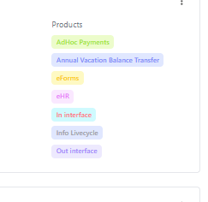
These are pre - configured and the server is not accepting any custom values
Inject a CSS payload in these fields:
- body { background: red !important; }
- body { outline: 10px solid lime !important; }
Injection of CSS field returns 400 Bad Request
Refer Screenshot attached below for evidence
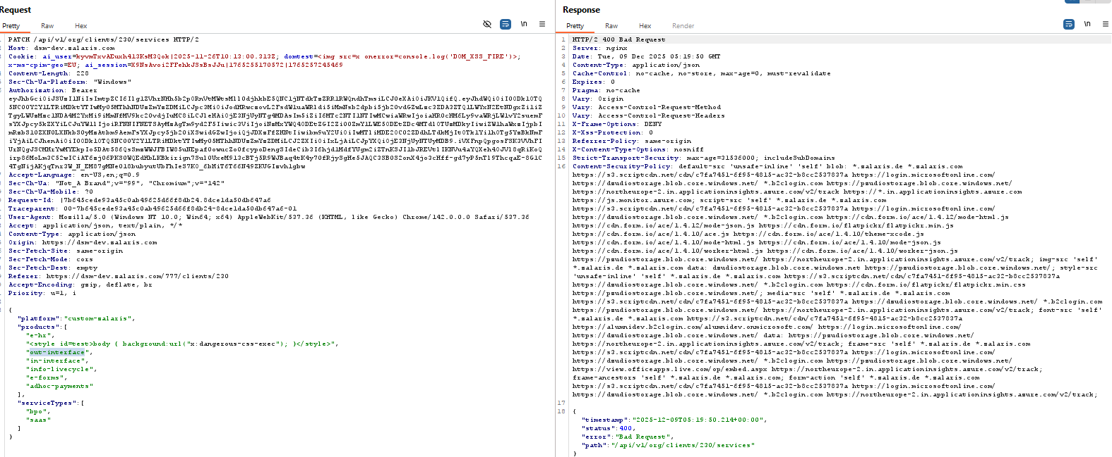
Submit/save the input and inspect the DOM (Ctrl+Shift+I → Elements tab).
Look for:
- Inline style attributes containing your payload
- If input appears in the DOM and styles are applied, it is a confirmed CSS reflection vulnerability.
The above style is not accepted
- CSP allows it AND the app uses dynamic style-sheet loading
No user controllable values passed onto to style sheet function. The alert is informational as inline scripts are enabled but no injection vectors are available that can lead to code execution

WORKLOG

When | What | Who | Recommended Action
05-12-2025 | Manually Tested Un-trusted Style Execution | CSOC | No Action needed the alert is informational

Input Returned in Response (stored)

Severity | NA
Finding Type | Informational

Links Tested
- /api/v1/org/clients/230/regions/no/contact-book [contactEmail JSON parameter]
- /api/v1/org/clients/230/regions/no/contact-book [name JSON parameter]

Description
Retrieval of stored input arises when user input is stored and later embedded into the application's responses.
Input being returned in application responses is not a vulnerability in its own right. However, it is a prerequisite for many client-side vulnerabilities, including cross-site scripting, open redirection, content spoofing, and response header injection. Additionally, some server-side vulnerabilities such as SQL injection are often easier to identify and exploit when input is returned in responses. In applications where input retrieval is rare and the environment is resistant to automated testing (for example, due to a web application firewall), it might be worth subjecting instances of it to focused manual testing.
Vulnerabilities resulting from retrieval of stored input are typically more serious than the equivalent reflected vulnerabilities because they do not require a separate delivery mechanism in order to reach target users. Depending on the affected functionality, ordinary users may be exploited during normal use of the application. Note that automated detection of stored data retrieval cannot reliably determine whether input that is persisted within the application can be retrieved by any other user, only by authenticated users, or only by the attacker themselves. You should review the functionality in which the vulnerability appears to determine whether the application's behavior can feasibly be used to compromise other application users.
Details

The input stored are either sanitized or the server returns 400 bad request

Refer Screenshot attached for evidence

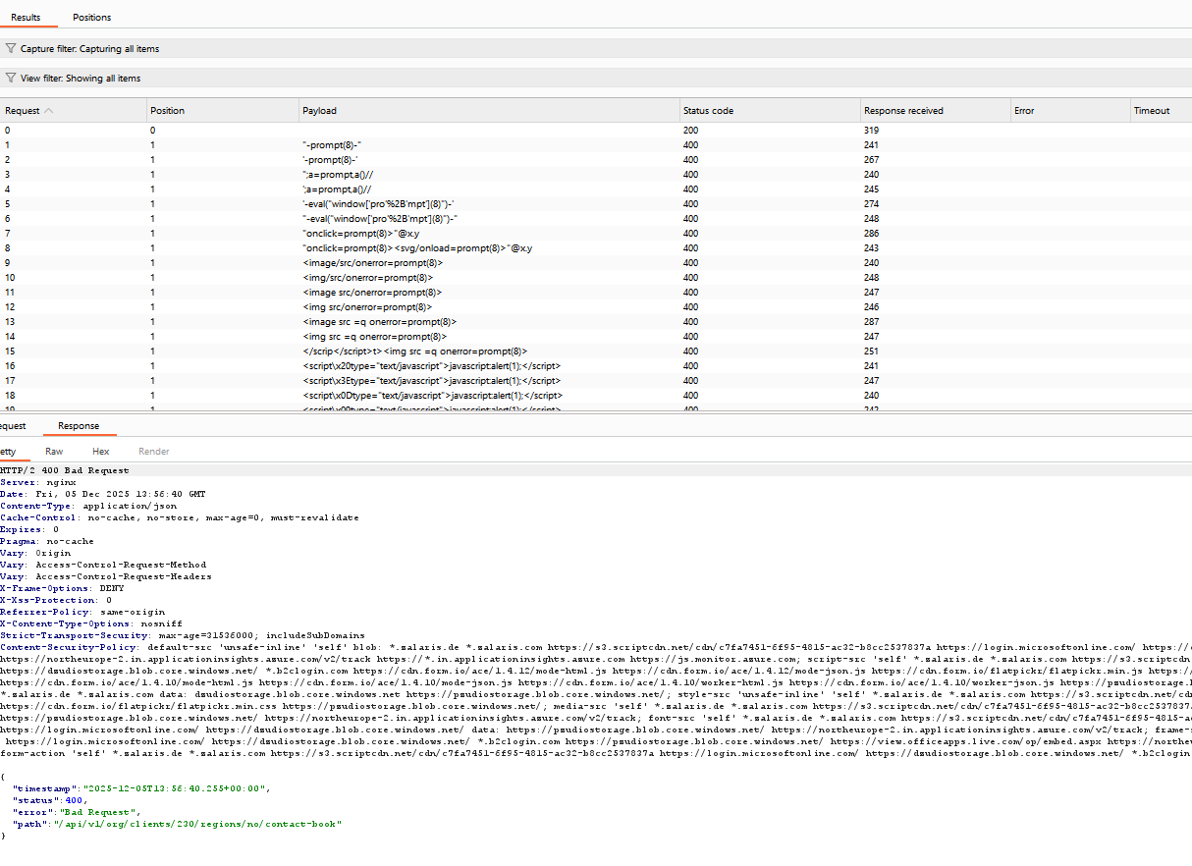

WORKLOG

When | What | Who | Recommended Action
05-12-2025 | Manually Tested Input returned in response (stored) | CSOC | No Action needed Informational

Input Returned in Response (Reflected)

Severity | NA
Finding Type | Informational

Links Tested
- /api/v1/dash/news [URL path filename]
- /api/v1/dash/news [URL path folder 1]
- /api/v1/dash/news [URL path folder 2]
- /api/v1/dash/news [URL path folder 3]
- /api/v1/dash/news/670509dee31630728bc84a22 [URL path folder 1]
- /api/v1/dash/news/670509dee31630728bc84a22 [URL path folder 2]
- /api/v1/dash/news/670509dee31630728bc84a22 [URL path folder 3]
- /api/v1/dash/news/670509dee31630728bc84a22 [URL path folder 4]
- /api/v1/fin/invoice-parties [URL path filename]
- /api/v1/fin/invoice-parties [URL path folder 1]
- /api/v1/fin/invoice-parties [URL path folder 2]
- /api/v1/fin/invoice-parties [URL path folder 3]
- /api/v1/fin/invoices [URL path folder 1]
- /api/v1/org/clients/230/regions/no [URL path folder 1]
- /api/v1/org/clients/230/regions/no [URL path folder 3]
- /api/v1/org/clients/230/regions/no [URL path folder 4]
- /api/v1/org/clients/230/regions/no [URL path folder 6]
- /api/v1/org/clients/230/regions/no/contact-book [URL path filename]
- /api/v1/org/clients/230/regions/no/contact-book [URL path folder 1]
- /api/v1/org/clients/230/regions/no/contact-book [URL path folder 2]
- /api/v1/org/clients/230/regions/no/contact-book [URL path folder 3]
- /api/v1/org/clients/230/regions/no/contact-book [URL path folder 4]
- /api/v1/org/clients/230/regions/no/contact-book [URL path folder 6]
- /api/v1/org/clients/230/regions/se [URL path folder 3]
- /api/v1/org/clients/230/regions/se [URL path folder 4]
- /api/v1/org/clients/definitions [URL path folder 3]
- /api/v1/org/clients/definitions [URL path folder 4]
- /api/v1/org/contacts/dsm-test-customer-230%40acme.com/avatar [URL path filename]
- /api/v1/org/contacts/dsm-test-customer-230%40acme.com/avatar [URL path folder 4]
- /api/v1/org/contacts/dsm-test-gsdm%40zalaris.com/avatar [URL path filename]
- /api/v1/org/contacts/dsm-test-gsdm%40zalaris.com/avatar [URL path folder 4]
- /api/v1/org/contacts/dsm-test-sdm-230-no%40zalaris.com/avatar [URL path filename]
- /api/v1/org/contacts/dsm-test-sdm-230-no%40zalaris.com/avatar [URL path folder 4]
- /api/v1/org/contacts/petter.person%40acme.com/avatar [URL path filename]
- /api/v1/org/contacts/petter.person%40acme.com/avatar [URL path folder 4]
- /api/v1/service-reports [URL path filename]
- /api/v1/service-reports/690b8b4816ffbe30e59895d5 [URL path folder 3]
- /api/v1/service-reports/690b8b4816ffbe30e59895e2 [URL path folder 3]
- /api/v1/stats/active-employee-group [URL path filename]
- /api/v1/stats/active-employee-group [URL path folder 3]
- /api/v1/users/me [URL path filename]
- /api/v1/users/me [URL path folder 3]

Description
Reflection of input arises when data is copied from a request and echoed into the application's immediate response.
Input being returned in application responses is not a vulnerability in its own right. However, it is a prerequisite for many client-side vulnerabilities, including cross-site scripting, open redirection, content spoofing, and response header injection. Additionally, some server-side vulnerabilities such as SQL injection are often easier to identify and exploit when input is returned in responses. In applications where input retrieval is rare and the environment is resistant to automated testing (for example, due to a web application firewall), it might be worth subjecting instances of it to focused manual testing.
Details

In all the URLs reported with the alert Input returned in Response (Reflected) the response was 400 , 404 Not found

When the path was added with prefix /777 server responded with 502 Bad Gateway

Refer the screenshot attached for evidence

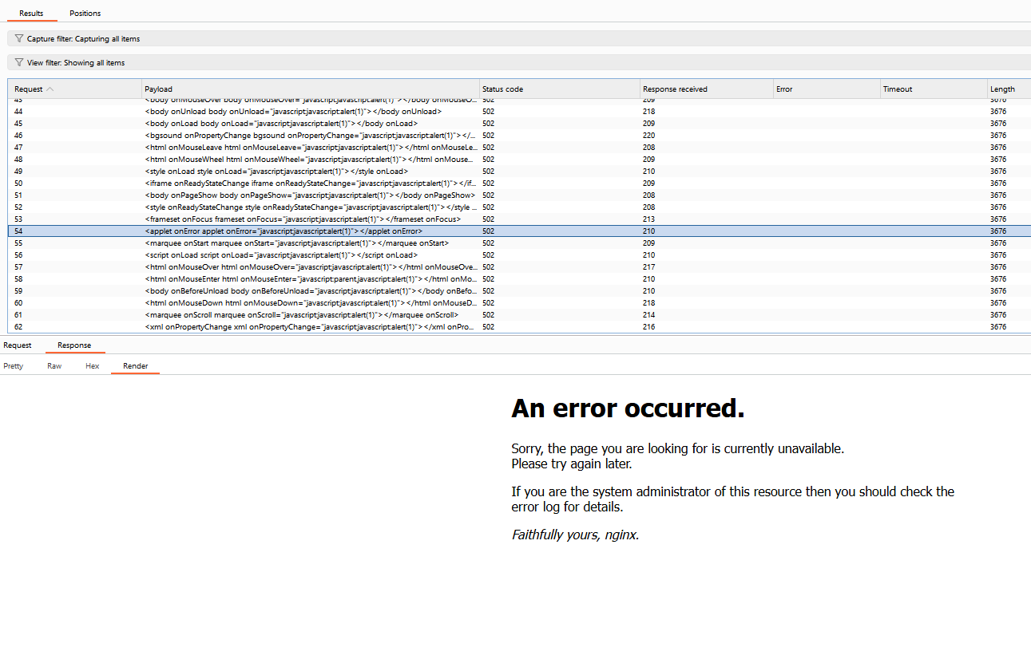

WORKLOG

When | What | Who | Recommended Action
05-12-2025 | Manually Tested Input returned in response (reflected) | CSOC | No Action needed Informational

HTML5 Storage Manipulation Test (DOM Based)

Severity | NA
Finding Type | False Positive

Description
DOM-based vulnerabilities arise when a client-side script reads data from a controllable part of the DOM (for example, the URL) and processes this data in an unsafe way.
HTML5 storage manipulation arises when a script stores controllable data in the HTML5 storage of the web browser (either localStorage or sessionStorage). An attacker may be able to use this behavior to construct a URL that, if visited by another application user, will cause the user's browser to store attacker-controllable data.
This behavior does not in itself constitute a security vulnerability. However, if the application later reads the data back from storage and processes it in an unsafe way, then an attacker may be able to leverage the storage mechanism to deliver other DOM-based attacks, such as cross-site scripting and JavaScript injection.
Burp Suite automatically identifies this issue using dynamic and static code analysis. Static analysis can lead to false positives that are not actually exploitable. If Burp Scanner has not provided any evidence resulting from dynamic analysis, you should review the relevant code and execution paths to determine whether this vulnerability is indeed present, or whether mitigations are in place that would prevent exploitation.
Details

The value that is passed on from the source to sink is related to Microsoft Azure Insights and is not sensitive . The alert is False positive

Refer Screenshot for evidence

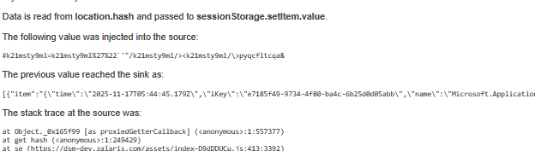

WORKLOG

When | What | Who | Recommended Action
05-12-2025 | Manually Tested HTML5 Storage Manipulation Test (DOM Based) | CSOC | No Action Needed False Positive.

Email address disclosed

Severity | NA
Finding Type | False Positive

Description

The following email addresses were disclosed in the response:
- dsm-test-sponsor-all@zalaris.com
- dsm-test-sdm-230-no@zalaris.com
- dsm-test-customer-230@acme.com
- dsm-test-gsdm@zalaris.com
- tore.bergvik@zalaris.com
- dsm-test-customer-230-2@acme.com
- ole-x2@acme.com
- kari.nordmann@acme.com
- dsm-test-customer-230-1@acme.com
- jens.jensen@acme.com
Details

The email address mentioned are part of the response and they are not disclosed to unauthorized user . The alert is False Positive

WORKLOG

When | What | Who | Recommended Action
05-12-2025 | Manually Tested Email Address Disclosed | CSOC | No Action Needed False Positive.

Cacheable HTTPS Response

Severity | NA
Finding Type | False Positive

Description

Unless directed otherwise, browsers may store a local cached copy of content received from web servers. Some browsers, including Internet Explorer, cache content accessed via HTTPS. If sensitive information in application responses is stored in the local cache, then this may be retrieved by other users who have access to the same computer at a future time
Links Tested

- /undefined

Details

The application will have Cache-able HTTPS response when the server caches the request or response and shares it to an unauthenticated attacker

The path mentioned is not accessible by an unauthorized attacker when accessed the page user is redirected to login page

Refer Screenshot for evidence

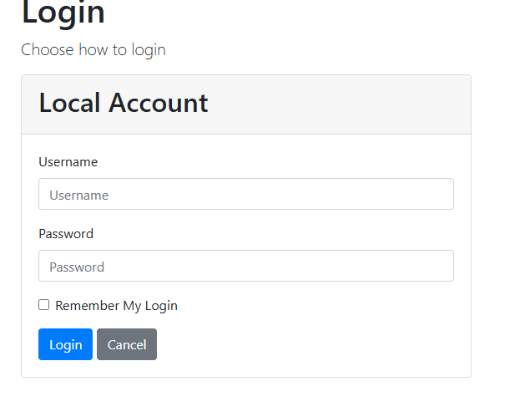

WORKLOG

When | What | Who | Recommended Action
05-12-2025 | Manually Tested Cacheable HTTPS Response | CSOC | No Action Needed False Positive.

